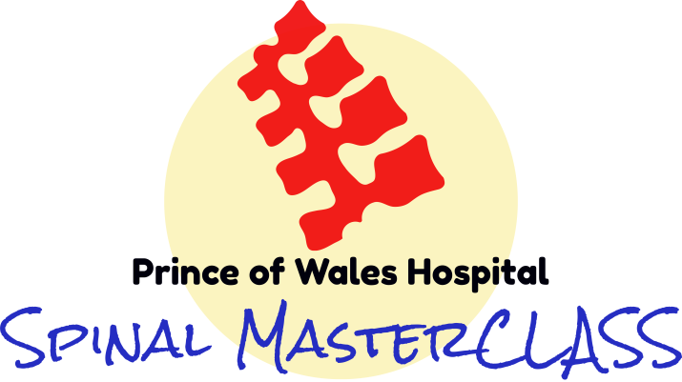

**Best Workshop EVER attended**-

AFRM Registrar, Brisbane

**Amazing selection of expert speakers … exhaustive and fun**

AFRM Registrar, Melbourne

**Focus on practical issues in SCI… Group discussions were amazing**-

Rehab Nurse, Sydney

**Should have done this sooner… great show POW team… almost wished it was longer**

AFRM Registrar, Sydney

**Found the format very practically useful…makes me feel very confident to deal with SCI patients**-

Rehab Specialist, Sydney

**Comprehensive revision of useful s@#$ in SCI management… most useful TESL spend**

Rehab Specialist, Gold Coast

**We WELCOME you all to this comprehensive journey in SCI Rehab that will encourage you to think with clarity in SCI**

Director POWH SCIU, Sydney

**Encourages team based thinking…Good overview**-

Physio, Melbourne

**Highly recommended**

Rehab Registrar, Sydney

**Registration**

**Spinal MasterCLASS 2025**

**11th Sept – 13th Sept**

**Follow the Link below to Register!**

***Representatives from developing countries will be  
offered discounted pricing, please email Cornelia***

**Payment Portal:**

[**Other-payments_Prince of Wales Hospital-Course Fee Spinal MasterCLASS**](https://nswhealth.sharepoint.com/:u:/r/sites/MoHCashShare-MOH/Shared%20Documents/HIPP%20Misc.%20and%20Donations%20Working%20Group/7.%20QR%20Codes%20for%20HE/SESLHD/other-payments_Prince%20of%20Wales%20Hospital-Course%20Fee%20%20Spinal%20MasterCLASS.svg?csf=1&web=1&e=XAXvep)

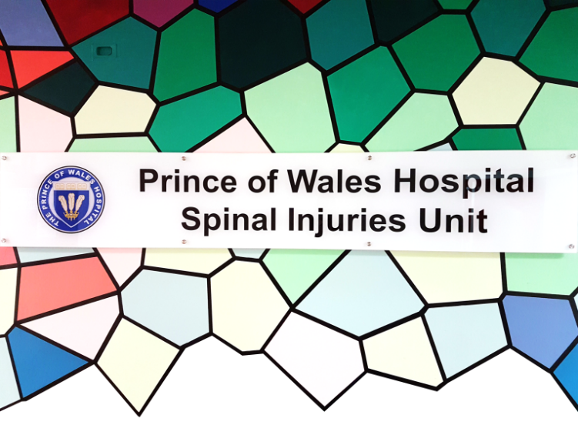

**Course information**

**Venue: Your favourite Couch with your Laptop**

**Date: 11th Sept – 13th Sept 2024**

**Time: AEST - Thurs-Fri- 8:30-5:30,**

**Sat- 8:30-1:00pm**

**Cost: Trainees/Allied Health/Nursing - A$350**

**MEDICAL Specialists - A$550**

**SESLHD Staff- A$105**

A secure link along with eHandbook will be sent to the candidates in the prior weeks with some pre reading information.

**Places are strictly limited and will run out!**

**Register by 05th Sept 2025**

**Contact persons:**

*For course information*

**Dr** **Sachin Shetty**

Email: [*sachin.shetty@health.nsw.gov.au*](mailto:sachin.shetty@health.nsw.gov.au)

*For registration information*

**Ms Cornelia Khaled**

P: (02) 9382 8599

F: (02) 9382 5620

E*: Cornelia.Khaled@health.nsw.gov.au*

**VIRTUAL**

**2025**

**11th Sept – 13th Sept**

**Venue**

Your favourite Couch

**Learning Objectives**

**Course Content**

**

* **Spinal MasterCLASS**

Every year, around the world, between 250 000 and 500 000 people suffer a spinal cord injury (SCI). They are a growing population with more complex and frequent than usual health presentations, the majority happening in healthcare facilities which are non-spinal specific.

It is very challenging to meet the specialised needs of this group of clients without having a specific training and understanding of their health care needs.

* **Content plan**

We have put together an overview of SCI management, tracking the journey from acute care to the key rehabilitation processes and interventions continuing towards longer term challenges with spinal cord injury. Various topics presented by subject experts encouraging active interaction. Key best practise messages will be summarised to give you more confidence in dealing with Spinal Cord injured Clients and provide appropriate care.

* **Who will benefit**

- Rehabilitation medicine trainees

- Allied health and Nursing professionals

- Specialists & GPs wanting to brush up & update their knowledge in SCI care.

**Q & A**

**Problem Solving**

**Health Maintenance**

**Social**

**Limitations**

**Environmental Barrier**

**Physical**

**Hurdles**

**Functional**

**Hurdles**

**Surgical/Medical Management**

**Psychological**

**Challenges**

**Acute Care**

* **Topics covered**
* ASIA assessment
* Acute surgical and medical management
* Spasticity
* Bladder and bowel issues
* Skin and pressure area
* SCI & Pain
* Sexuality and fertility
* Multidisciplinary team roles
* Wheelchair and equipment
* Vocation and return to work
* Patient perspectives

Case discussions